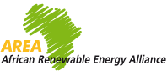
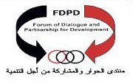
الشبكة الأفريقية للطاقة المتجددة
CALL FOR PARTICIPATION:
Papers, Exhibits and Sponsorships

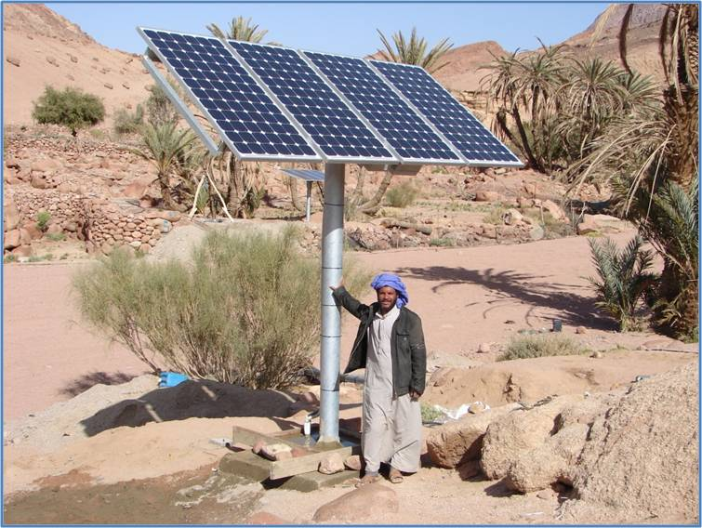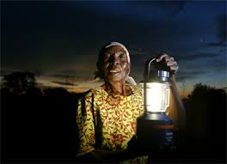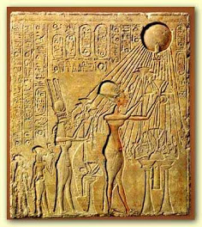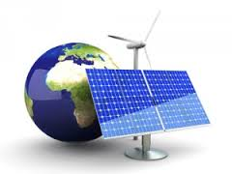
AREA - EGYPT CONFRENCE
TOWARDS 100% RENEWABLES AND SUSTAINABLE COMMUNITIES FOR AFRICA

The American University in Cairo, New Cairo
April 27-30, 2014
EGYPT

Children are the Future of Our Nation and Renewables are the Future of Our Planet

Conference Fees:
All Students: Free, Egyptians: 450 EGP, Non-Egyptians: 150 $ US

For Information, Enquiries, and Registration please contact:
Prof. Salah Arafa, Conference Coordinator, www.aucegypt.edu
www.area-net.org Mobile: +202–01001985625, smarafa@aucegypt.edu
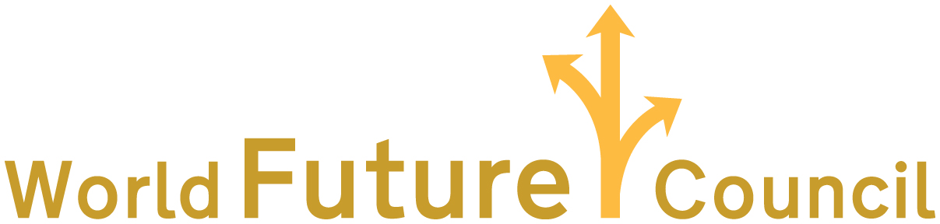
AREA - EGYPT CONFRENCE

TOWARDS 100% RENEWABLES AND SUSTAINABLE COMMUNITIES FOR AFRICA

The American University in Cairo, New Cairo
April 27-30, 2014
EGYPT

Children are the Future of Our Nation and Renewables are the Future of Our Planet

PROGRAM

Remarks | Activity | Place | Time | Day
 | Arrivals of Non-Egyptian Participants  Reception | Cairo | 8:00 pm | April 26
 | Registration  Opening Session  Opening Exhibition  Working Sessions | AUC | 9:00 am | April 27
 | Working Sessions  Field Visits I | AUC  Cairo-  6th October | 9:30 am  12:30 pm | April 28
 | Working Sessions  Closing Session | AUC | 9:30 am  4:30 pm | April 29
 | Field Visits II  Departures | New Basaisa  South Sinai  Red Sea  Cairo | 8:00 am | April 30

